Q1: In pdf document on the dropbox link, it is mentioned that logistic regression calculates the probabilities of belonging one group rather than the other. It is also explained that the dependent variable should be dichotomous. I cannot imagine that the dependent variable is dichotomous but not categorical. Can we explain a little bit more?

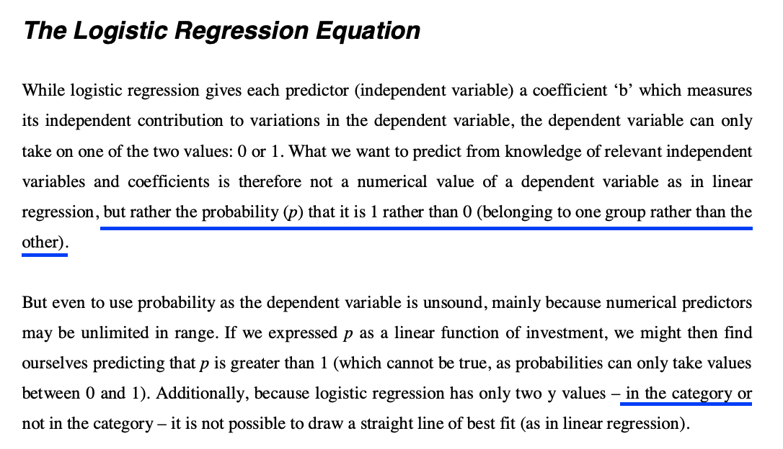

Q2: In the book of “Customer Analytics with R”, what can be an example of natural churn rate which a company has unavoidably?

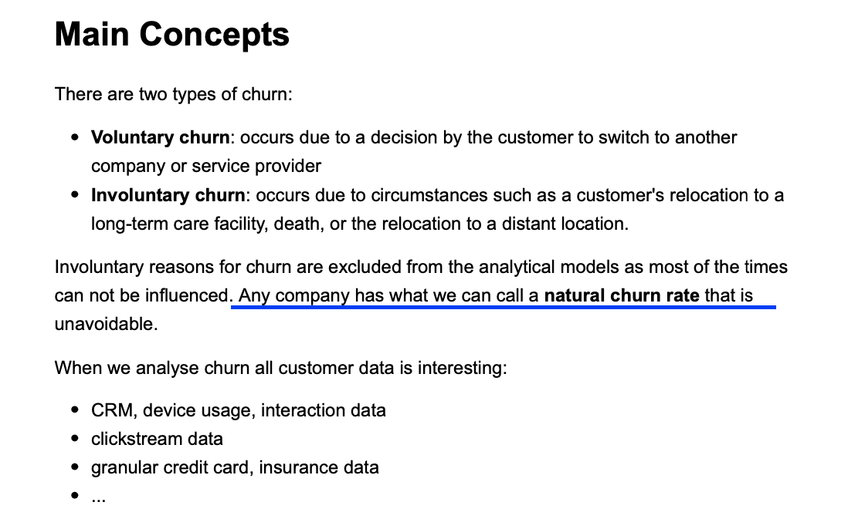

Q3: In the DataCamp chapter, I did not understand the difference between the two models below. While regression works with all of the columns in logitModelFull, logitModelNew calculated by stepwise regression. when we look at the accuracies of these two models, they are approximately the same. Could the effect of the stepwise regression on accuracy be so insignificant?

In sample fit full model

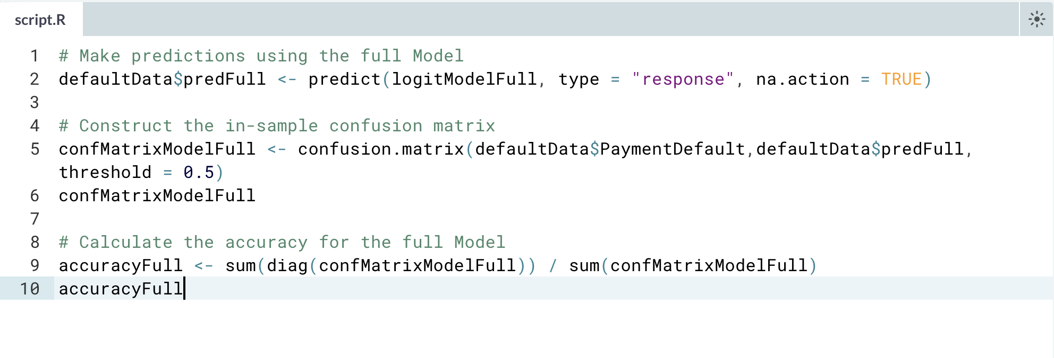

In sample fit restricted model

